***PROJECT REPORT***

***OBJECTIVES***

Complete online solution for SEO and SMO techniques for

making website popular and get higher ranking on search engines.

Tailor-made design with value-added features for gaining and retaining customers on the site.

Unlimited changes without functional difficulties for addressing ever-changing business

requirements. Safe and secure payment options and mechanism for generating trust among

customer and building up their confidence for the particular site. Technical assistance for any

difficulty for seamless operation of the site. All these and some other objective make Ecommerce website design company a choice of numerous companies for establishing online store.

***INTRODUCTION***

E-comers is a transaction of buying or selling online .Electronic commerce draws on technologies such as mobile commerce, electronic funds transfer , supply chain management, Internet marketing, online transaction processing, electronic data interchange, inventory management systems, and automated data collection system.

This project is the project of e-commerce it is website of laptop. Where no of laptops are available for sell. There are many website available for selling gagets. But this is the shop made only for laptops . We see many website like flipkart, amazon but this website provide many option like user can choose there CPU ,as there choice like how many bits of RAM they want or ROM also ,etc.

***ANALYSIS OF PROBLEM***

By analysing problems of user we find that they have to search many website to buy laptop, they ask many people which will be best computer and so on. But then also they couldn’t find correct information. But our lapyshop provide users many information .Such as we provide information like the best cheap Laptops of 2017**,** The Best Gamming Laptops of 2017, The Best Ultraportable Laptops of 2017.So as we visit we see many options as above user get such kind of information. But this kind of guidence will never given by any other website.

Another thing about this website is that user can choose there Motherboard, RAM, Processor, Graphics Card, Power Supply, Power Supply. This kind of facility never seen in any other commercial website. On this website we also provide different brand on one site only as per users choice.

*IMPLEMENTETION*

As you visit to website you will find many options such as home, news, contacts, brand and so on. If click on  then you will find some information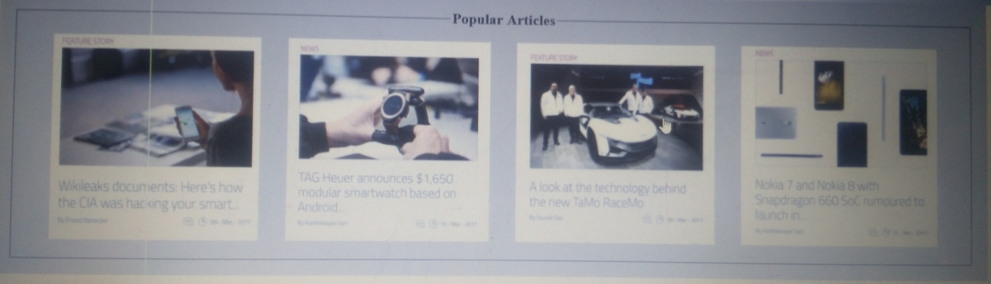like some popular articles .

And if you will go to then you will got many options and information such as

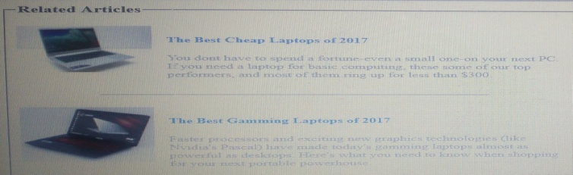 

And option for choosing CPU





If you click on then you will some information about us and our contacts also.

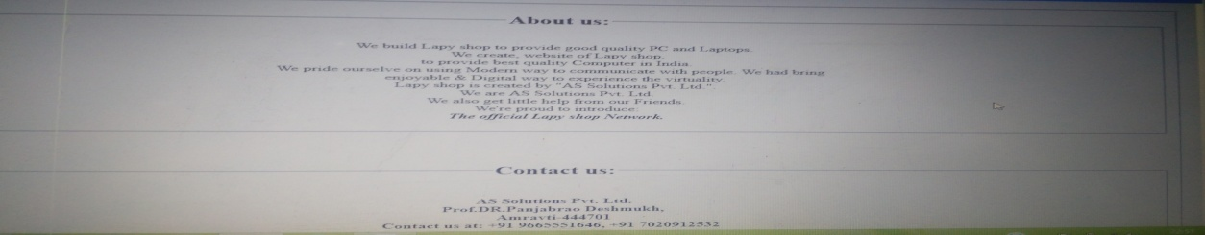

Then if you click on  then you got the option for brand of laptop.

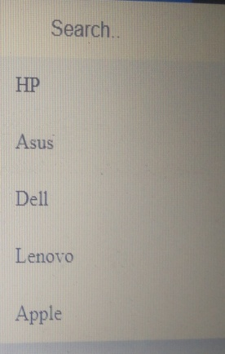 after that if you choose any brand such as hp then you get the best rating of hp laptop.

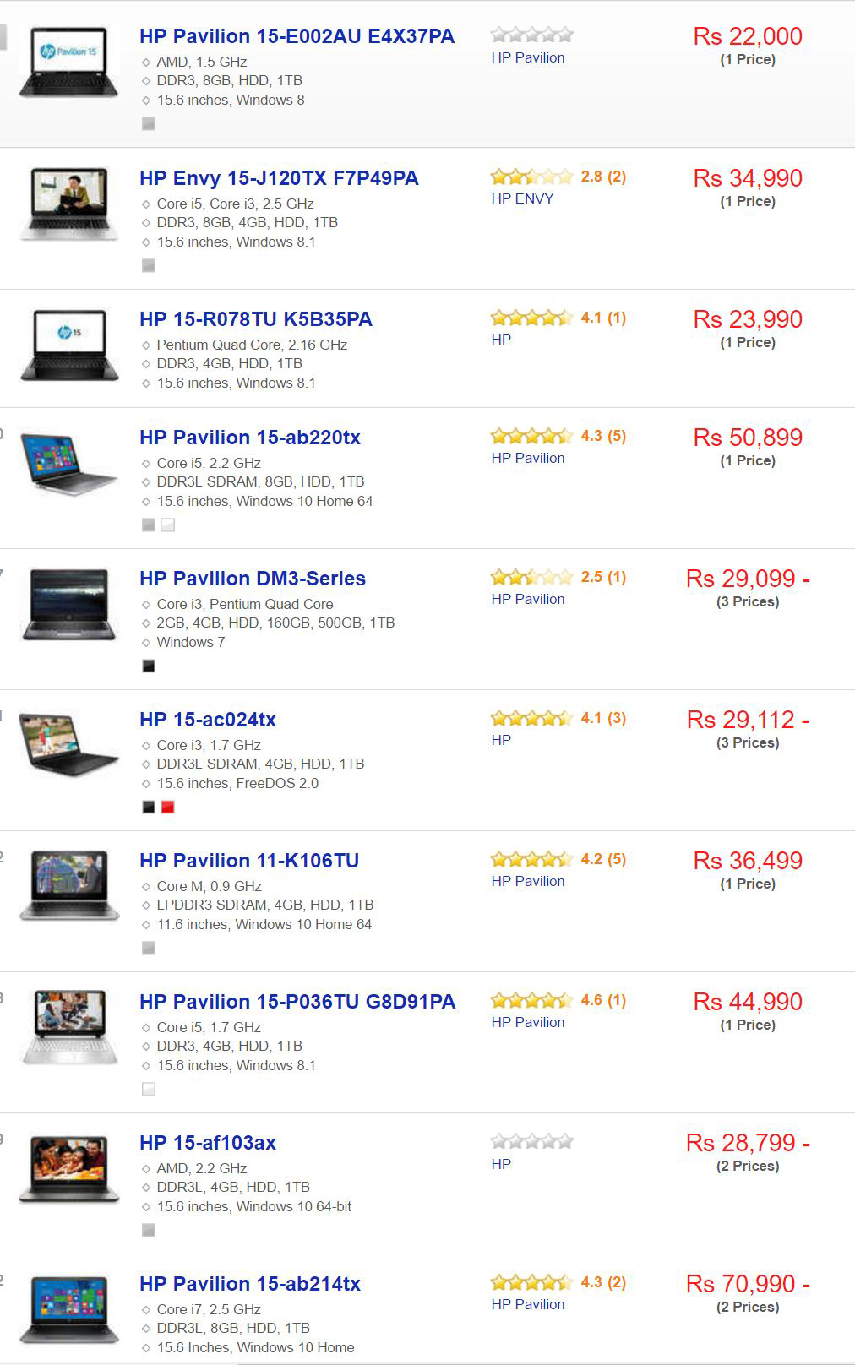

If you choose asus then you will get the rate are as follows

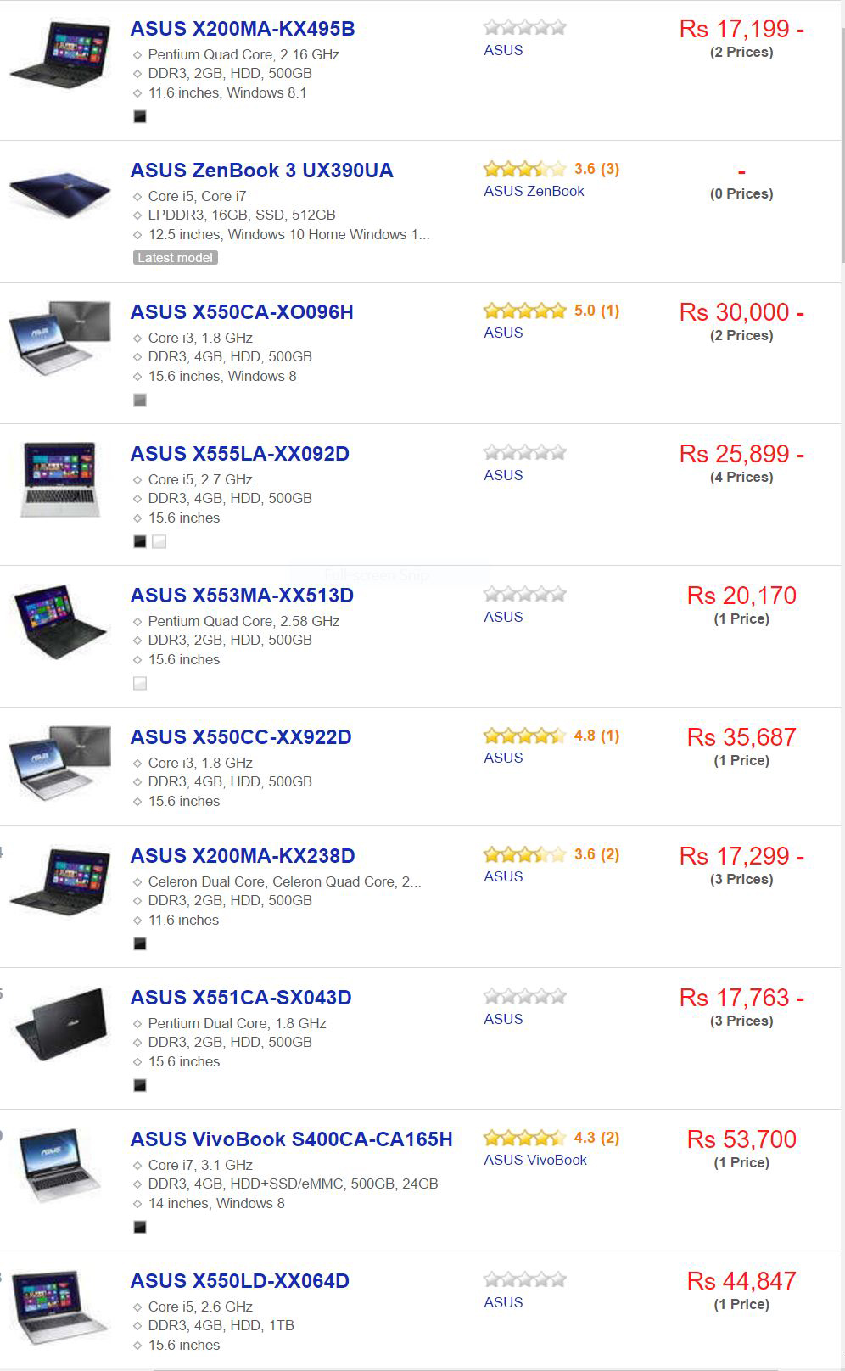

And if you choose dell then you will get the rate

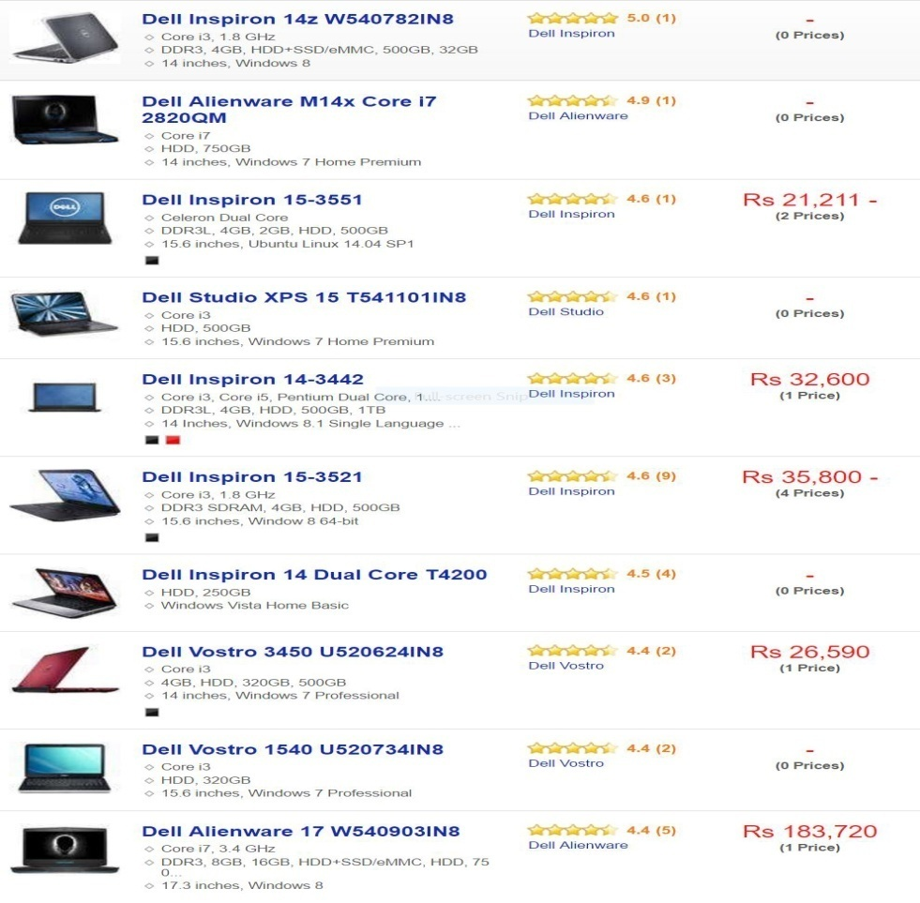

If you choose Lenovo then you will got the rate

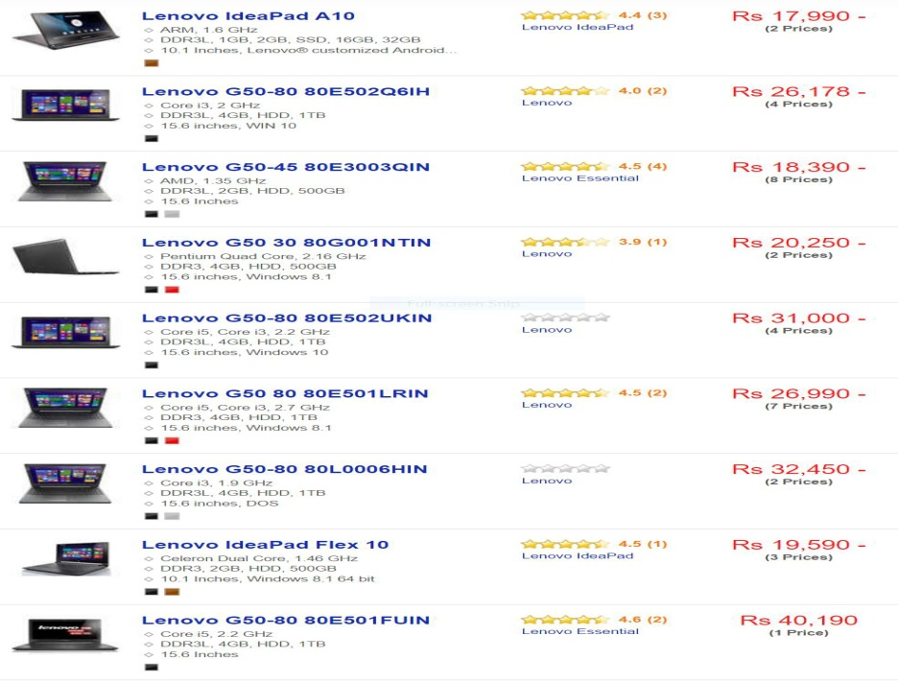

And if you choose apple then you will got the rate

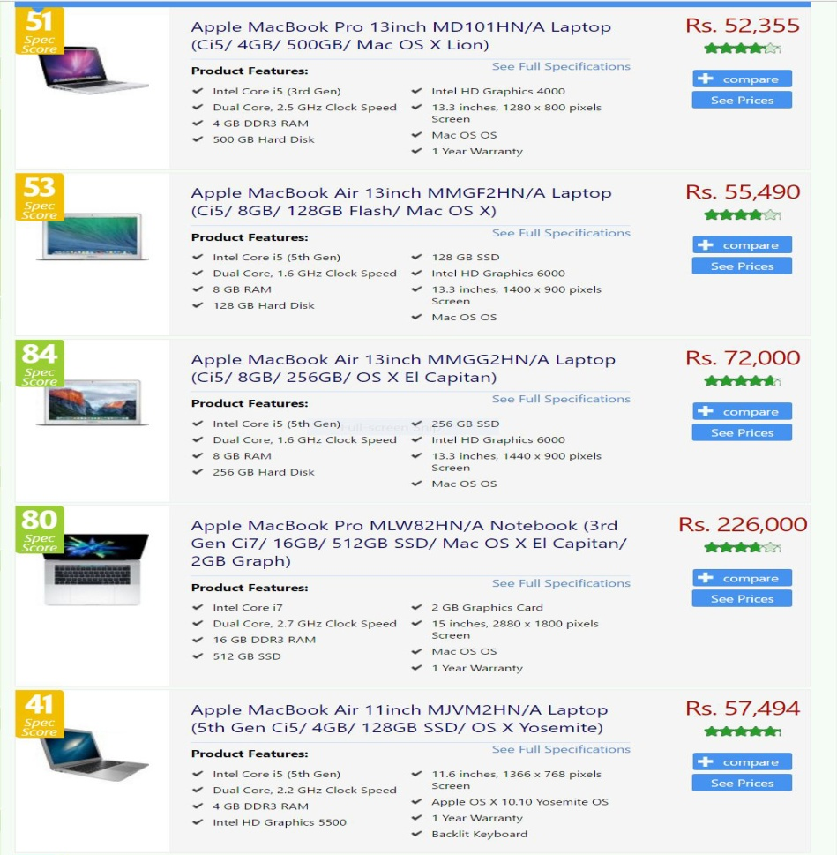

So this what the implementation of lapyshop.

***RESULT ANALYSIS***

The project of lapyshop is being made only and only for selling the laptop. As compare to other websites, in other e-commerce website user get good laptop but our lapyshop provide user not only proper guidance but good personalised experience to the user with most popular brands laptop. As we visit to any other e-commerce website we just have to search many site , have to visit on many pages and check rating and then select the particular laptop till then a visitor get frosted and leave the site. But in our case this will not happen because we provide the best of the best options of laptop and give there rating.

***CONCLUSION***

In general, today’s business must always strive to create the next best thing that consumers will want because consumer continue to desire their products, services etc. to continuosly be faster, better ,and cheaper. In this world of new technology, businesses need to accommodate to the new types of consumer needs and trend because it will prove to be vital to their business success and survival. So according to users need lapyshop provide the best laptop services.

***Future scope***

Future scope of e commerce is very bright for both buyer and seller will get benefit of it. Seller can get a very wide area to sell their products online through which they can get many buyers from their country as well from abroad.

In recent years, E-commerce had grown at the rate of 88% which is considerd as fastest growth by any sector in Indian. In that case lapyshop website will be successful because it provide better option for laptop in advance way.

***REFERENCE***

http://Notionkart .com

<http://www.ecomdash.com>

http://www.quora.com